

*Xerox Document Centre Setup* Guide for FlowPort

This document is intended for use by FlowPort System Administrators when configuring the following Xerox Document Centres to scan to a FlowPort server:

* Document Centre 240/255/265/460/470/480/490
* Document Centre 220/230/332/340/432/420/425/432/440 There are two basic things you must do on the Document Centre:
* Designating a “repository” on the document centre. This is the IP address of the FlowPort server.
* Setting up a default scan template.

The procedures in this guide are provided as examples only. Because of firmware differences, the screens you see may be different, however you may use the concepts presented here.

# Configuring a Document Centre 240/255/265/460/470/480/490 with Centreware Internet Services

Verify that the Scan-to-File feature is installed on the Document Centre. Print a Configuration sheet and check the installed options list for Scan-to-File. If the Scan-to-File is not listed, contact your Xerox service representative to obtain and install the Scan-to-File kit. You can also call 1-800-ASK-XEROX for information about obtaining and installing this feature.

## FlowPort Repository & Template Setup

The Xerox Document Centre uses templates and repositories to control the disposition of scanned documents. Information about these templates and repositories is stored inside the Document Centre and is accessible through the Web server embedded in the device. The Document Centre provides a default template, a number of named template (optional), a default public repository, and four other configurable public repositories.

Templates are shown as choices on the Document Centre Touch Screen. The default template is named “@default.xst” and it is the first template shown in the template list on the screen. The Xerox Document Centre uses *templates* and *repositories* to control the disposition of scanned documents. Information about these templates and repositories is stored inside the Document Centre and is accessible through the Web server embedded in the device. The Document Centre provides a default template, a number of named templates (optional), a default public repository, and four other configurable public repositories.

Templates are shown as choices on the Document Centre Touch Screen. The default template is named “@default.xst” and it is the first template shown in the template list on the screen.

Repositories are shown as choices for template setup in the Document Centre Web-based administration tool. Each repository has the following settings:

* Repository List
* Protocols
* File Server IP Address
* Directory Path
* Login Name
* Password

## FlowPort Repository Setup

The following settings for the Default Repository and Template Pool Setup are recommended.

* 1. In your Web browser’s **Address** (or **Location**) box, enter the TCP/IP address of your Document Centre.

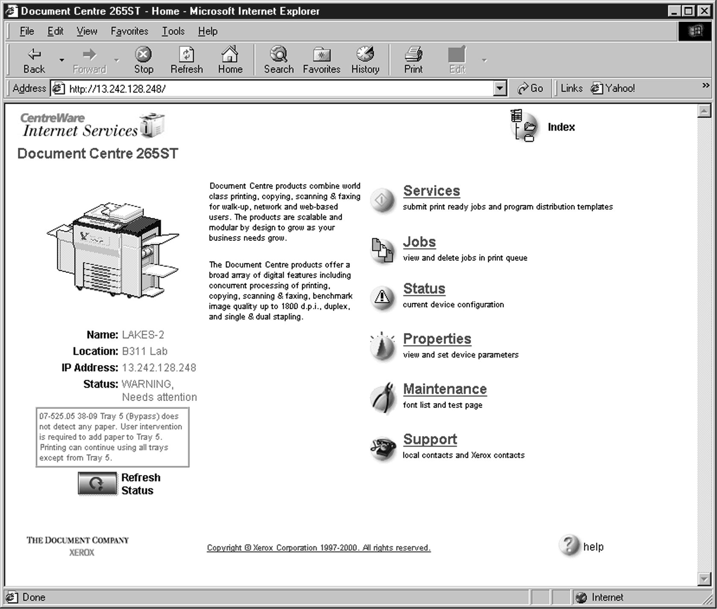

* 1. Click on **Properties.**
  2. In the Properties column (left side of screen), click on the plus (+) sign for the

**Services** folder. The properties for the Document Centre will display as shown

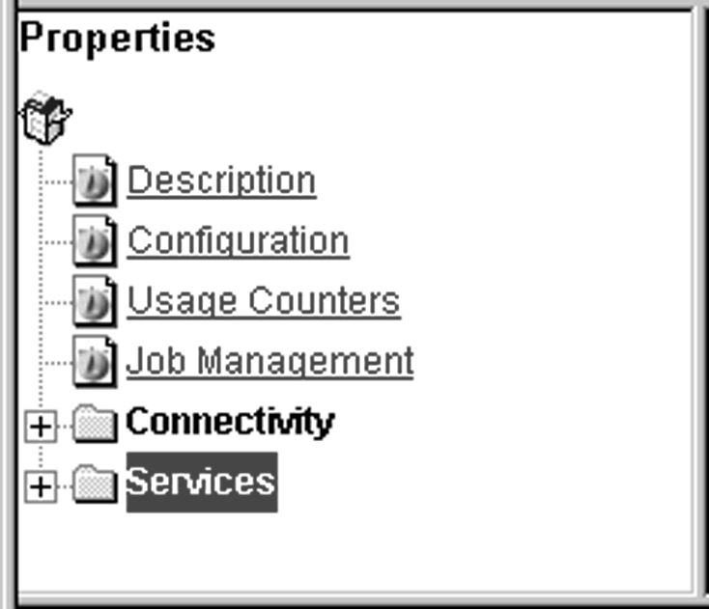below.

* 1. Click on the plus (+) sign for the **Distribution Templates**.
  2. 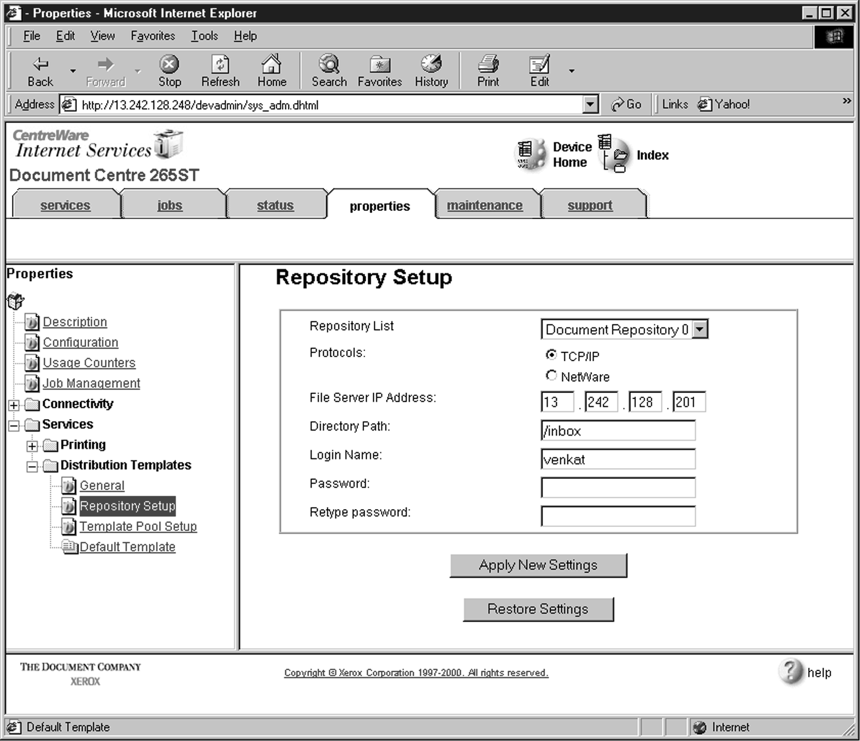Click the **Repository Setup** link.
  3. Under **Repository Setup**, perform the following:

**Repository List:** Select **Document Repository 0**. Check with your Xerox Document Centre System Administrator to make sure the Repository is not in use.

**NOTE:** Depending on the printer software model, there may only be 1 repository. Some models will have Document Repositories of 0-4 or 1-5.

**Protocols:** Select **TCP/IP**.

**File Server IP Address:** Enter the TCP/IP address of your FlowPort server. Contact your Network Administrator if you do not know the address. In some versions, you may need to enter a port number. In this case, enter 21.

**Directory Path:** Enter **/**.

**Login Name:** Enter the guest account user name (**NSA** is the default guest account user name).

**Password:** Enter the FTP password twice (**nsa** is the default guest password).

***Note: If you have changed the NSA FTP user name or password in the FlowPort NSA Protocol Service configuration, enter the new user name and password here to enable FTP access.***

* 1. Click on **Apply New Settings**.
  2. A **Login** window may display. Enter **admin** for the user name followed by your password. If you do not know your password, contact your printer system

administrator.

 ***Note: The user name and password are case sensitive.***

## FlowPort Template Setup

1. 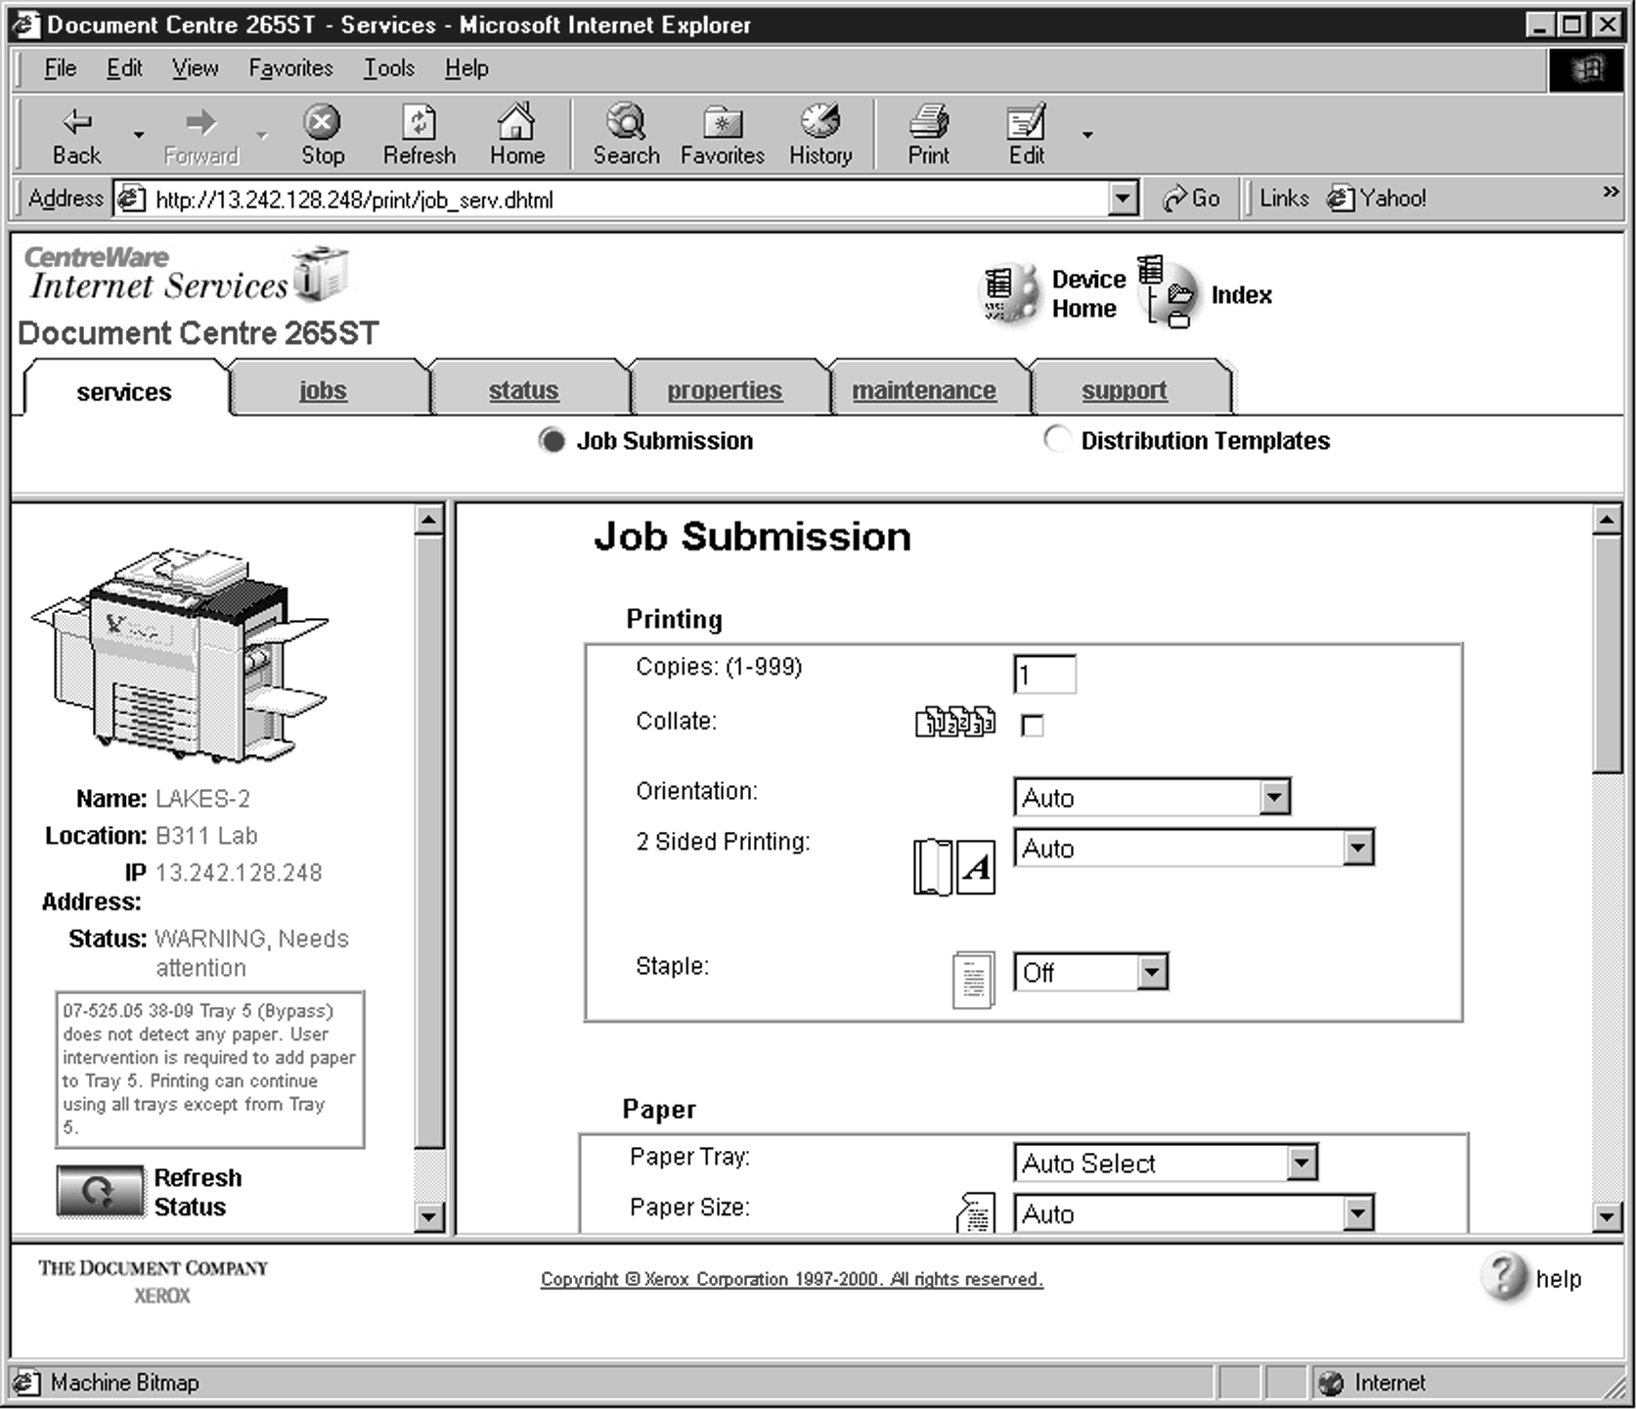Click on the **Services** tab. The **Job Submission** page displays as shown below.
2. 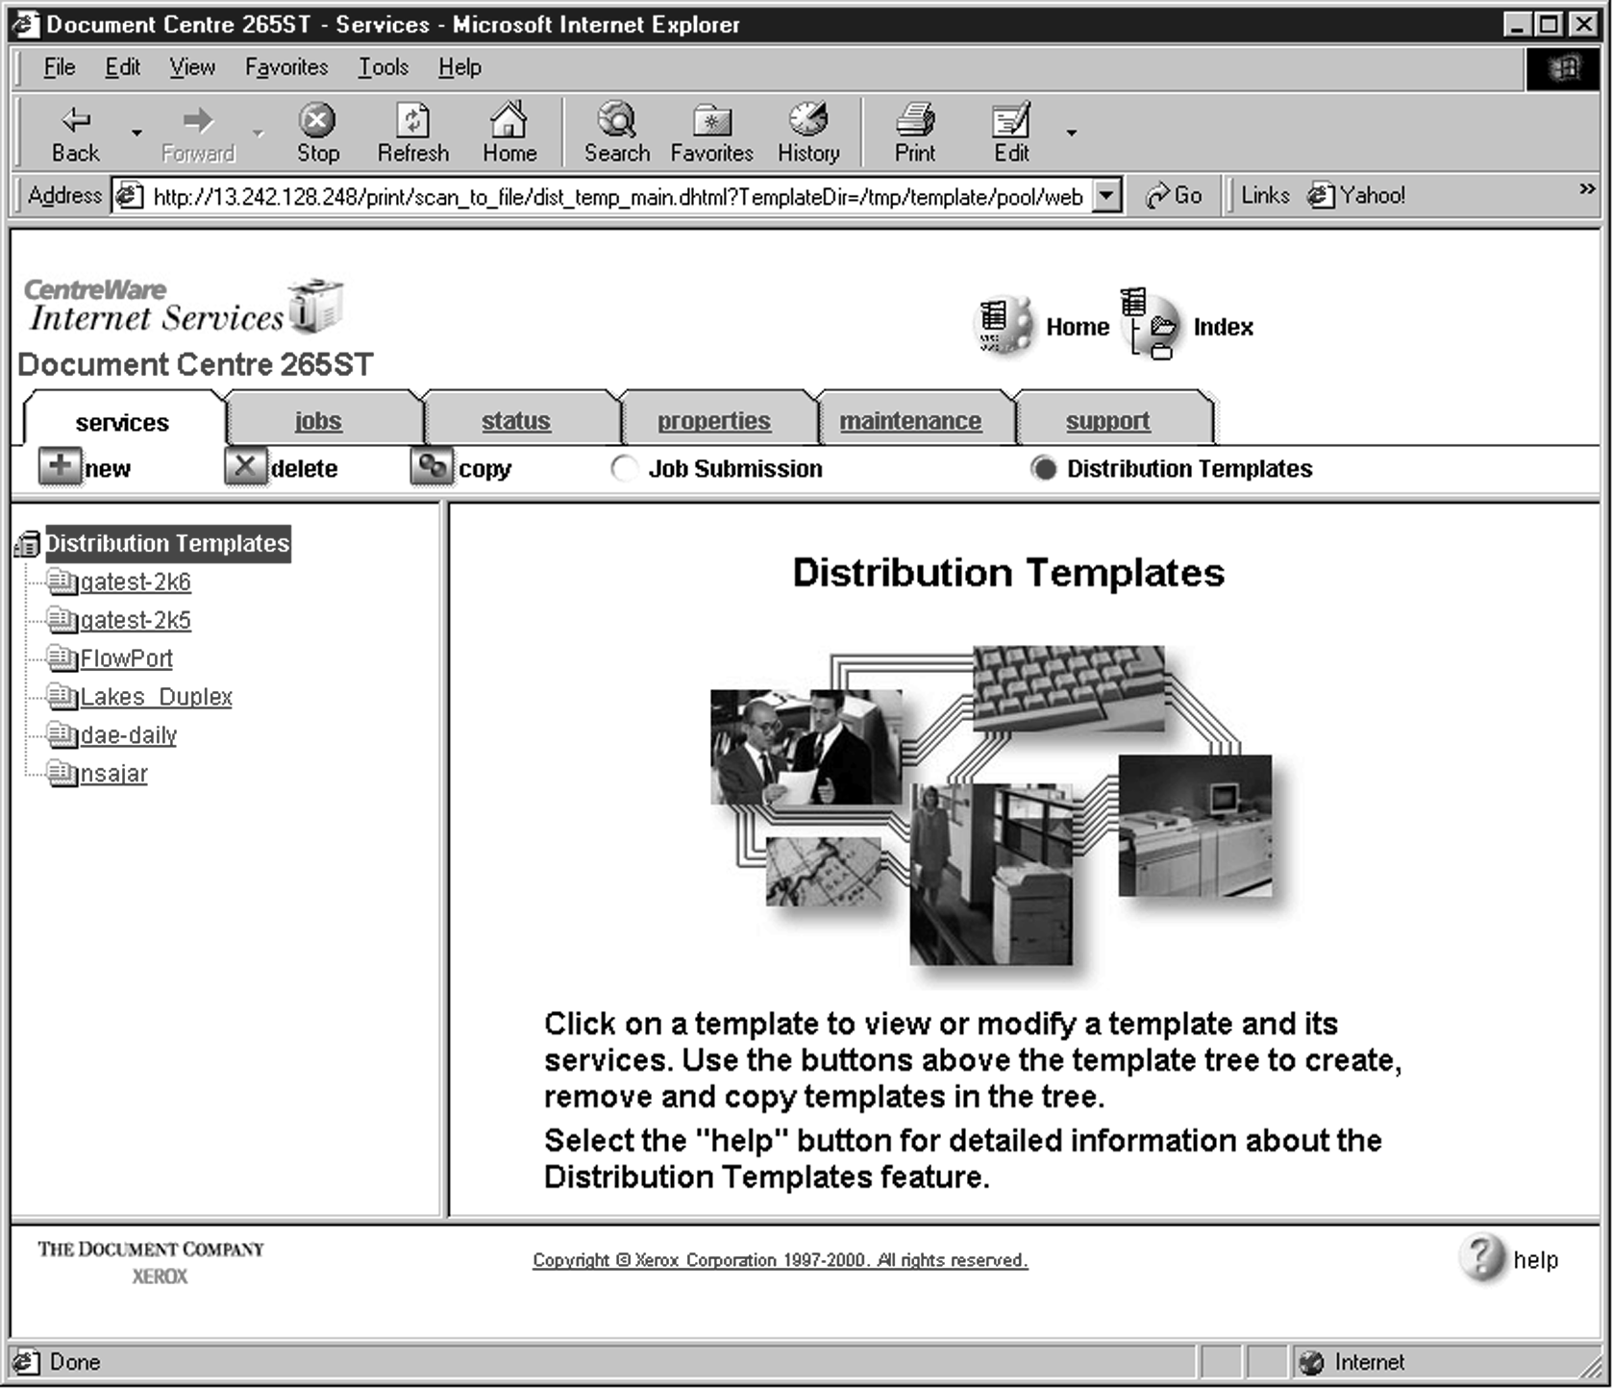Click on the **Distribution Templates** button.
3. 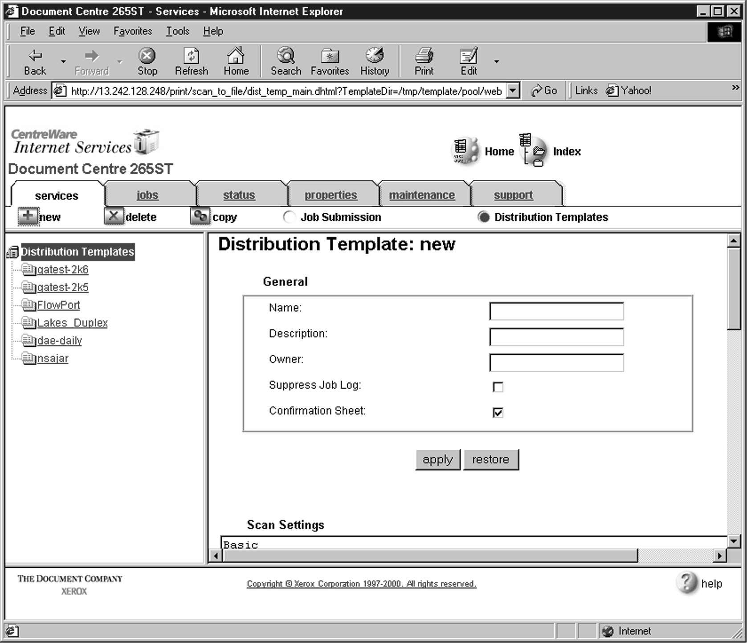Under the Services tab, click on the **[+] new** button.
4. In the **General** settings box, enter the following:

**Name**: Type **FlowPort** (or any name that would let users know that this is the FlowPort template. It can be up to eight characters in length).

**Description**: Type **Scan to FlowPort**.

**Owner**: Type **your name** or the FlowPort administrator’s name.

1. Review the Scan Settings. Click on **Edit** if you need to change the default settings.

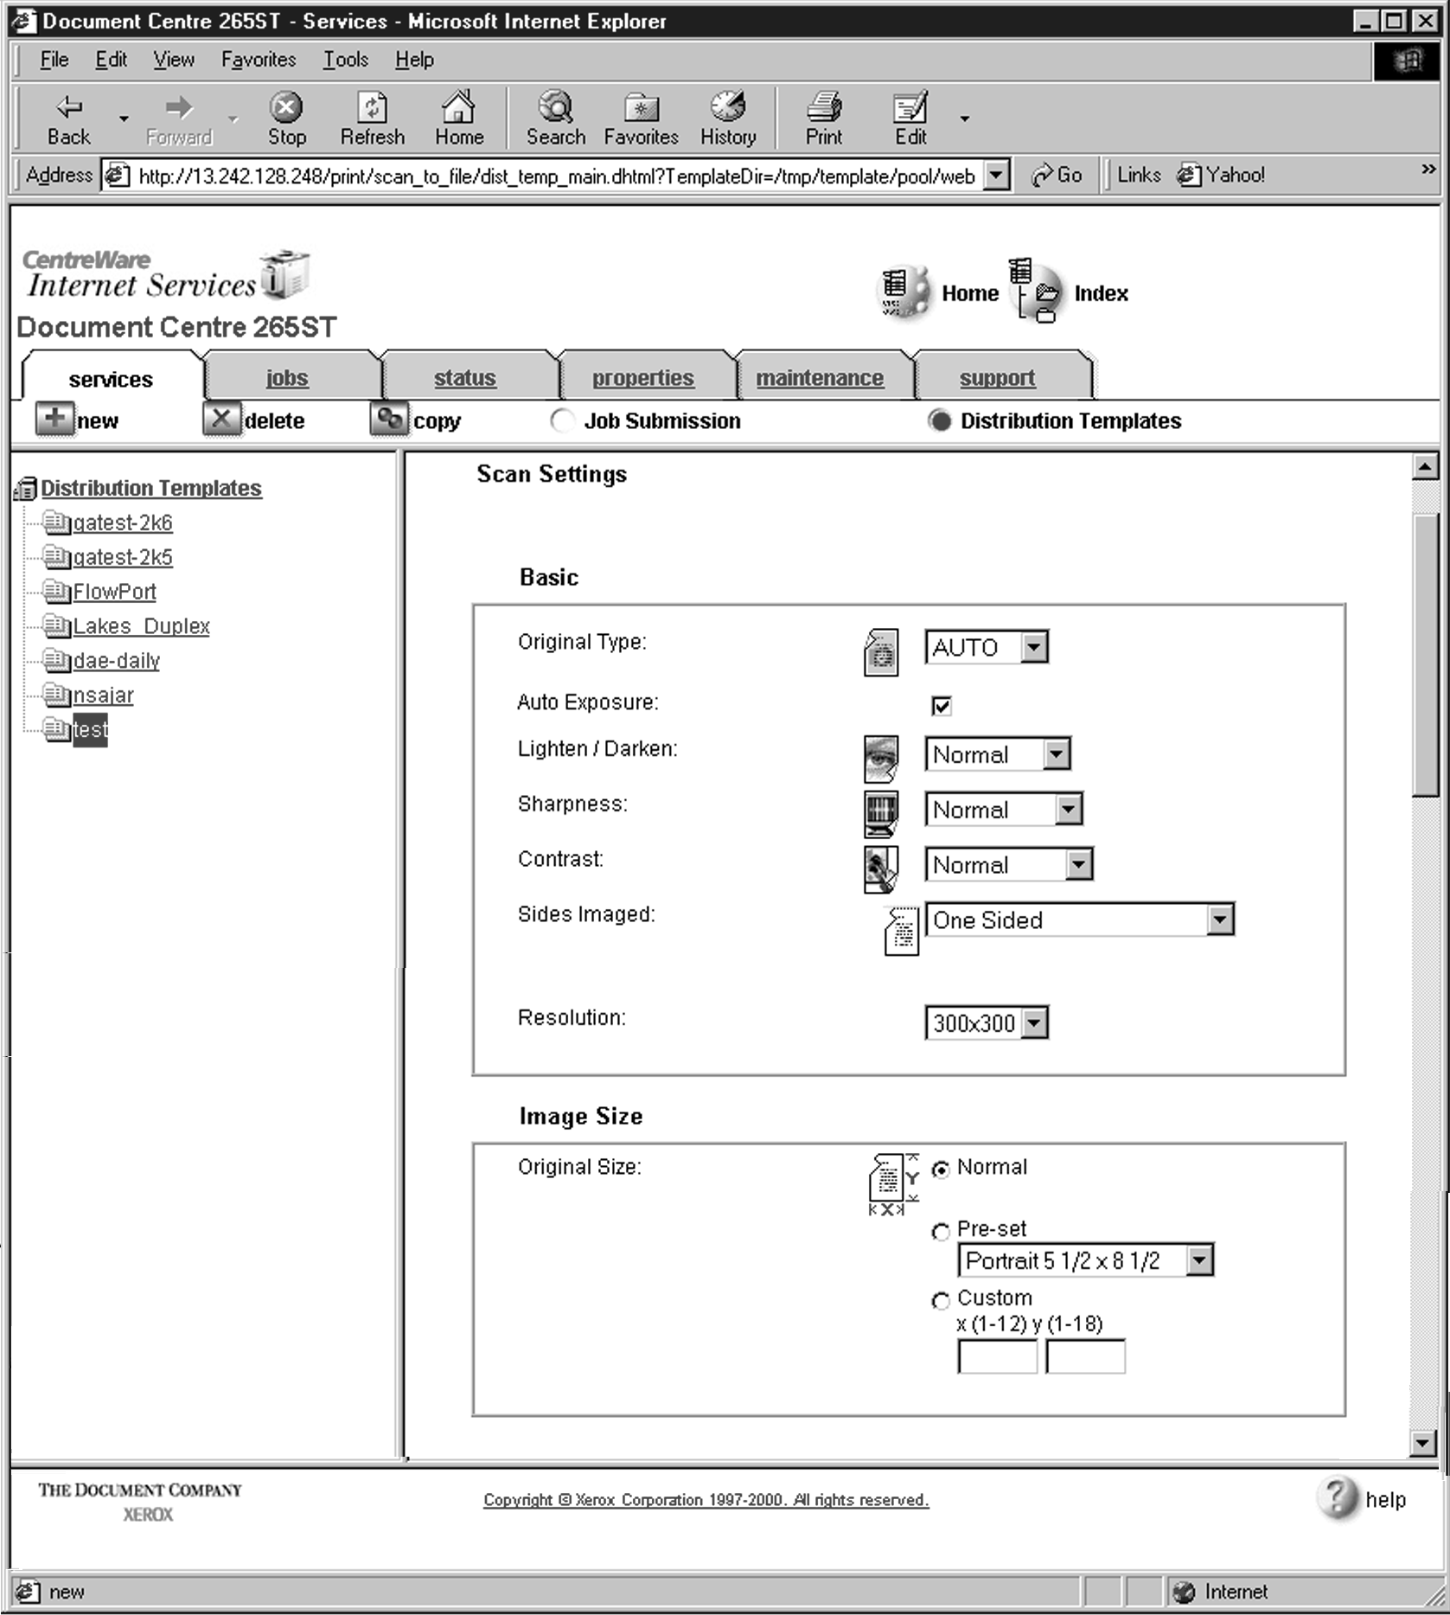

Text

1. In the Distribution area, specify a **Destination**. Select **Public Internet Folder**

from the New Destination list, and click **add**.

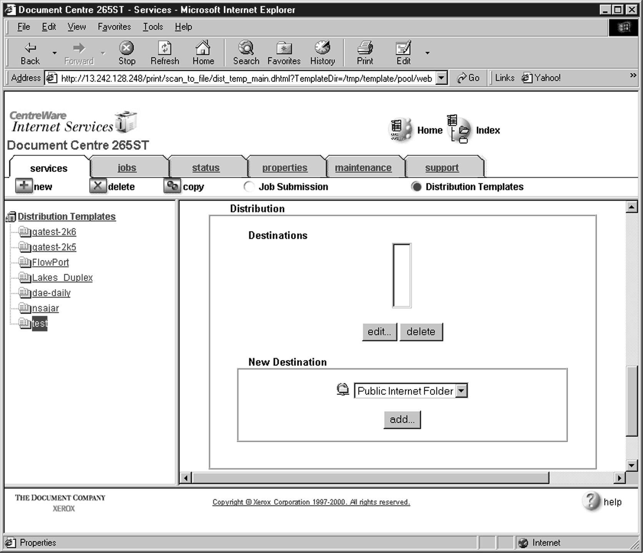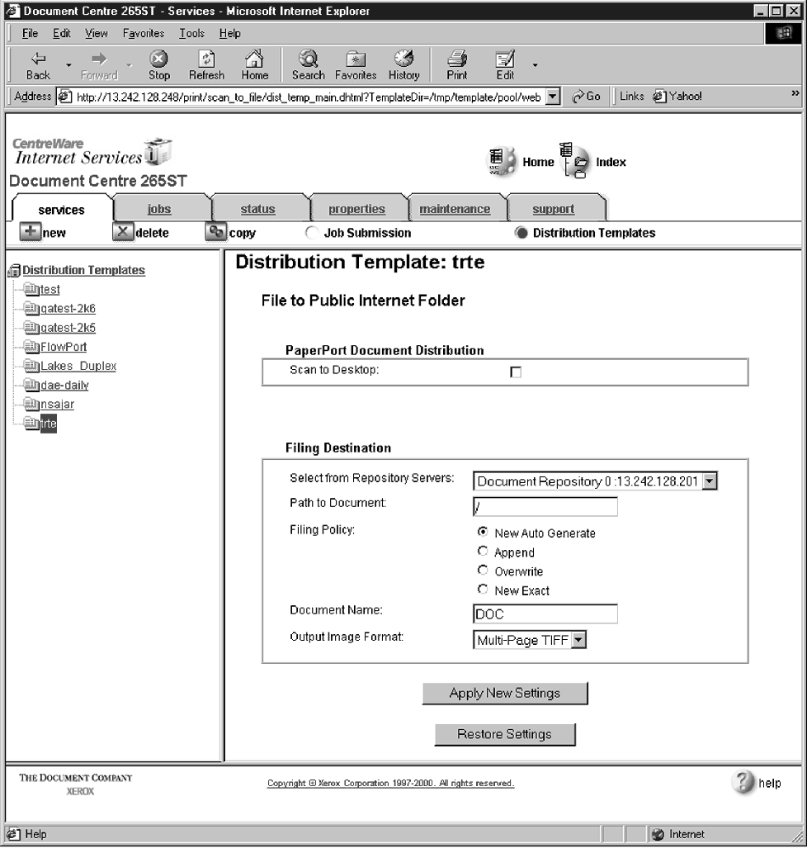

1. In the list of **Select from Repository Servers**, select repository that points to the FlowPort server.
2. Type the Path to Document **/**
3. Check the Filing Policy **New Auto Generate**.
4. Document name is DOC.
5. Select the Output Image Format **Multi-Page TIFF**.
6. Click on **Apply New Settings**. The Document Centre is ready to use FlowPort.

***Note: This setup provides users Guest access (Trusted/Shared) to FlowPort. If a higher authentication level is required, users should use their FlowPort Login sheet.***

## Testing the FlowPort Template

To check that the Document Centre is ready for FlowPort use, perform the following test:

1. At the Document Centre, place a document in the scanner.
2. Select the FlowPort template and select Scan.

***Note: If the Document Centre is properly configured, a DC confirmation sheet will be printed confirming that the scan to FlowPort was successful, otherwise an error report with some specific failure notice will be printed. If the scan to FlowPort was successful a FlowPort confirmation sheet will also print.***

# Configuring a Document Centre 220/230/332/340/432/420/425/ 432/440 with Centreware Internet Services

Verify that the Scan-to-File feature is installed on the Document Centre. Print a Configuration sheet and check the installed options list for Scan-to-File. If the Scan-to-File is not listed, contact your Xerox service representative to obtain and install the Scan-to-File kit. You can also call 1-800-ASK-XEROX for information about obtaining and installing this feature.

## FlowPort Repository and Template Setup

The Xerox Document Centre uses templates and repositories to control the disposition of scanned documents. Information about these templates and repositories is stored inside the Document Centre and is accessible through the Web server embedded in the device. The Document Centre provides a default template, a number of named template (optional), a default public repository, and four other configurable public repositories.

Templates are shown as choices on the Document Centre Touch Screen. The default template is named “@default.xst” and it is the first template shown in the template list on the screen. The Xerox Document Centre uses *templates* and *repositories* to control the disposition of scanned documents. Information about these templates and repositories is stored inside the Document Centre and is accessible through the Web server embedded in the device. The Document Centre provides a default template, a number of named templates (optional), a default public repository, and four other configurable public repositories.

Templates are shown as choices on the Document Centre Touch Screen. The default template is named “@default.xst” and it is the first template shown in the template list on the screen.

Repositories are shown as choices for template setup in the Document Centre Web-based administration tool. Each repository has the following settings:

* Repository List
* Protocols
* File Server IP Address
* Directory Path
* Login Name
* Password

## FlowPort Repository Setup

The following settings for the FlowPort Repository setup are recommended.

1. In your Web browser’s **Address** (or **Location**) box, enter the TCP/IP address of your Document Centre.

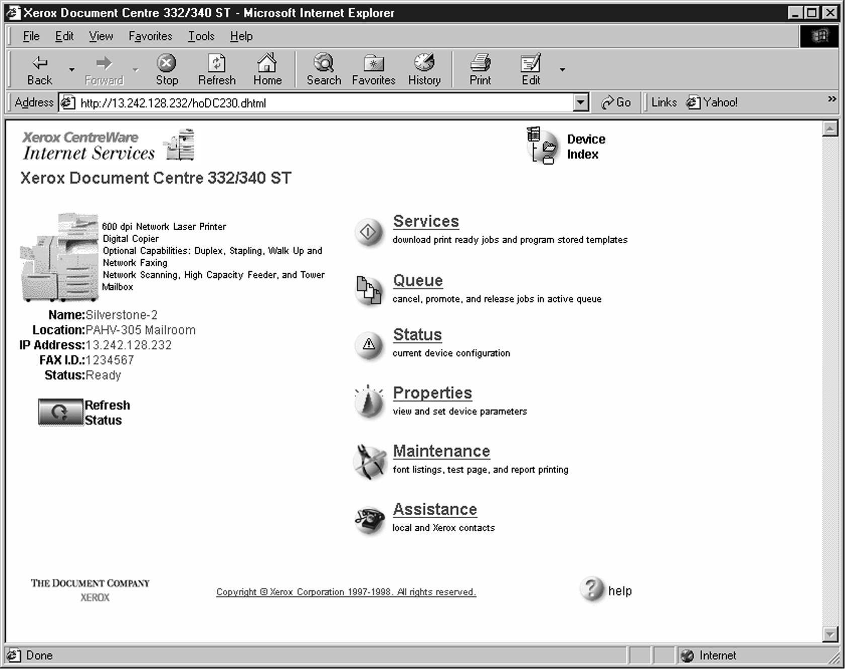

1. Click on **Properties.**
2. Click on **[+] Services.**
3. Click on **[+] Stored Templates**
4. Click on **Repository Setup**.

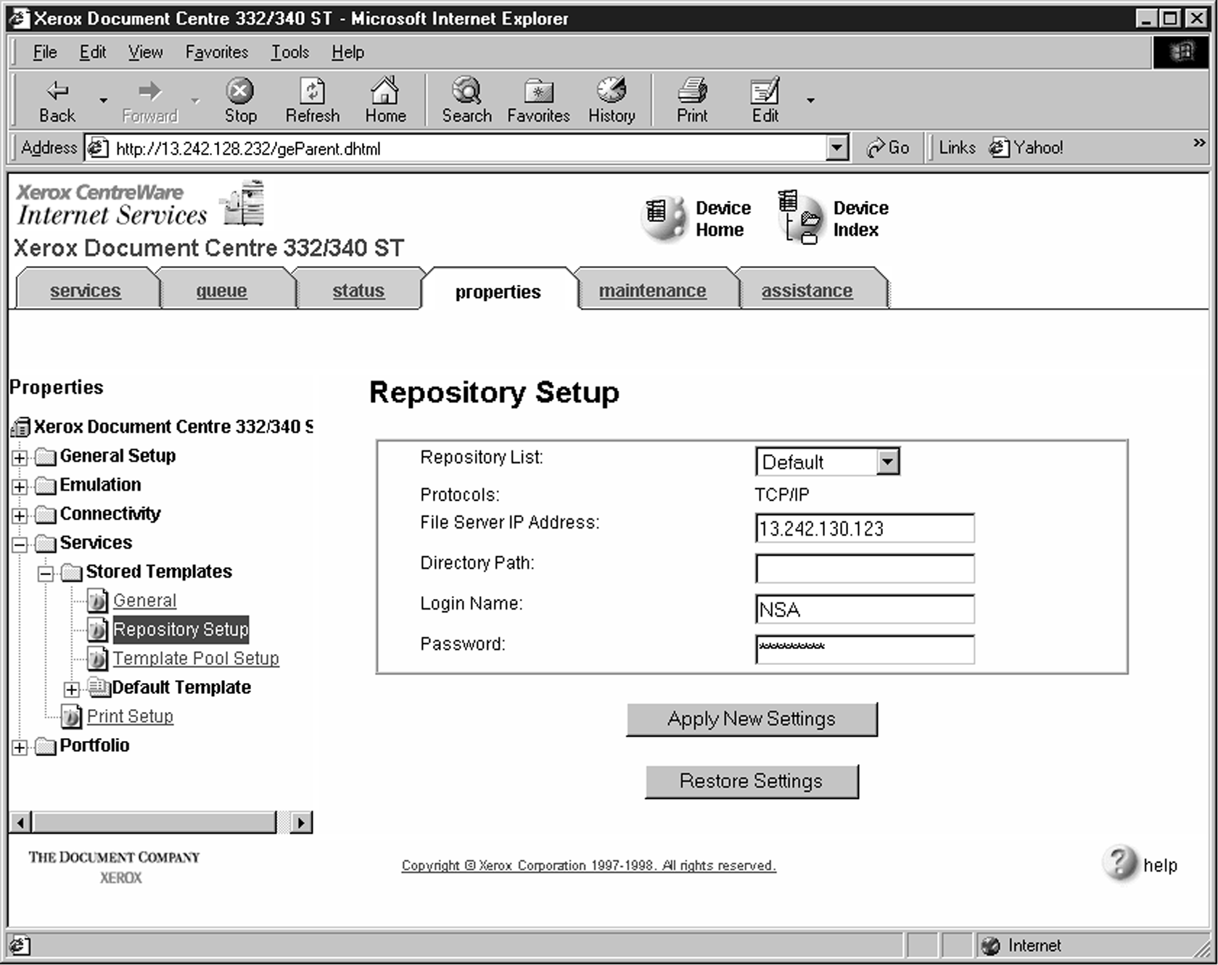

**/**

1. Select an unused repository from the **Repository List** (Default is recommneded).
2. Verify that the protocol is **TCP/IP.**
3. Type the **File Server IP address** (the IP address of your FlowPort server).
4. Type the Directory Path **/**
5. Type the login name **NSA**, and the password **nsa**.
6. Click on **Apply New Settings**.
7. In the dialog box that appears, type the admin User Name and Password of the Document Centre, and click **OK**.

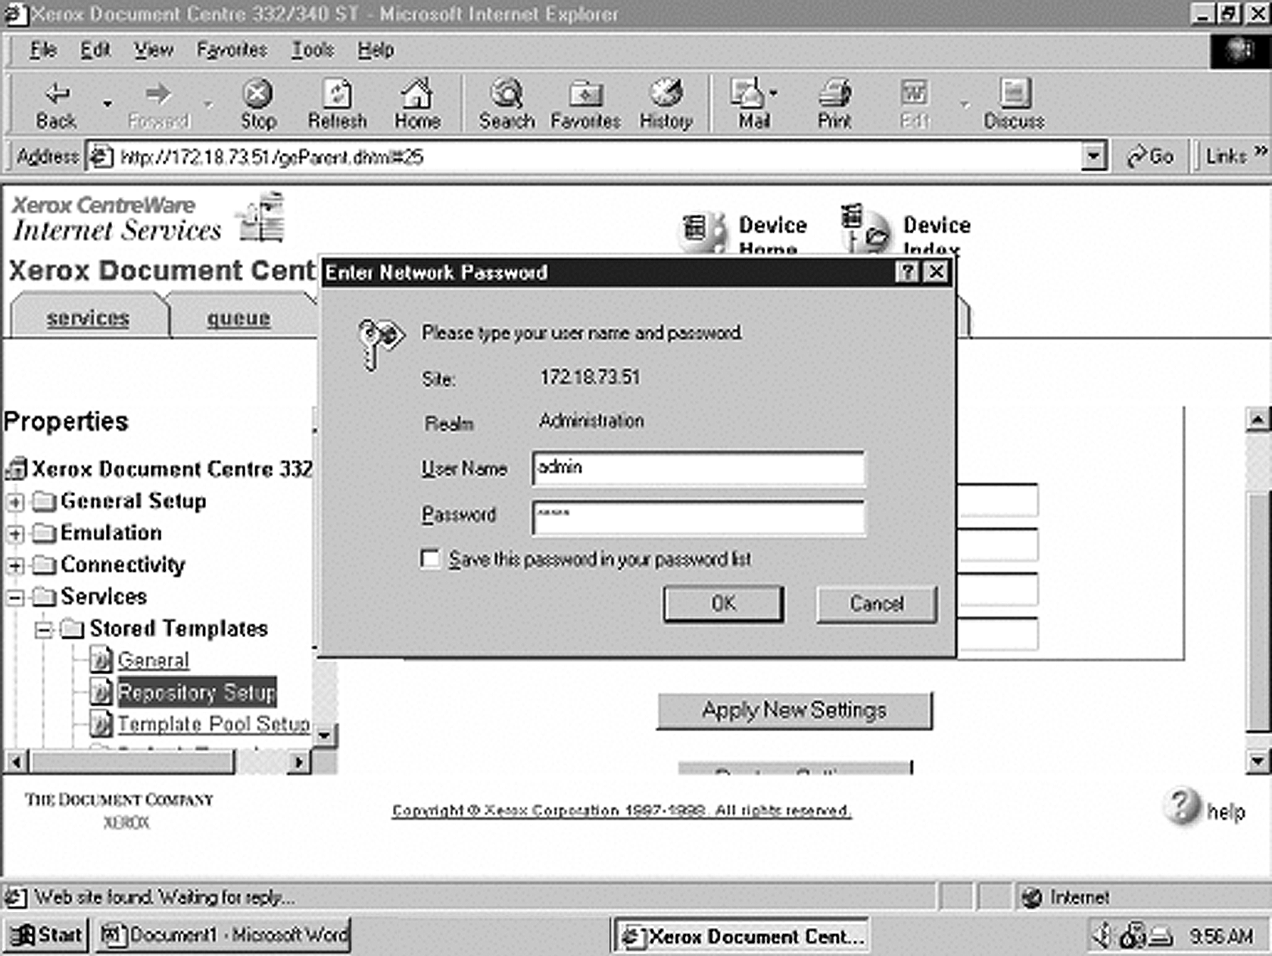

## FlowPort Template Setup

1. Next, you need to set up the scan template that you will use when scanning to FlowPort server. Select **Device Index**.

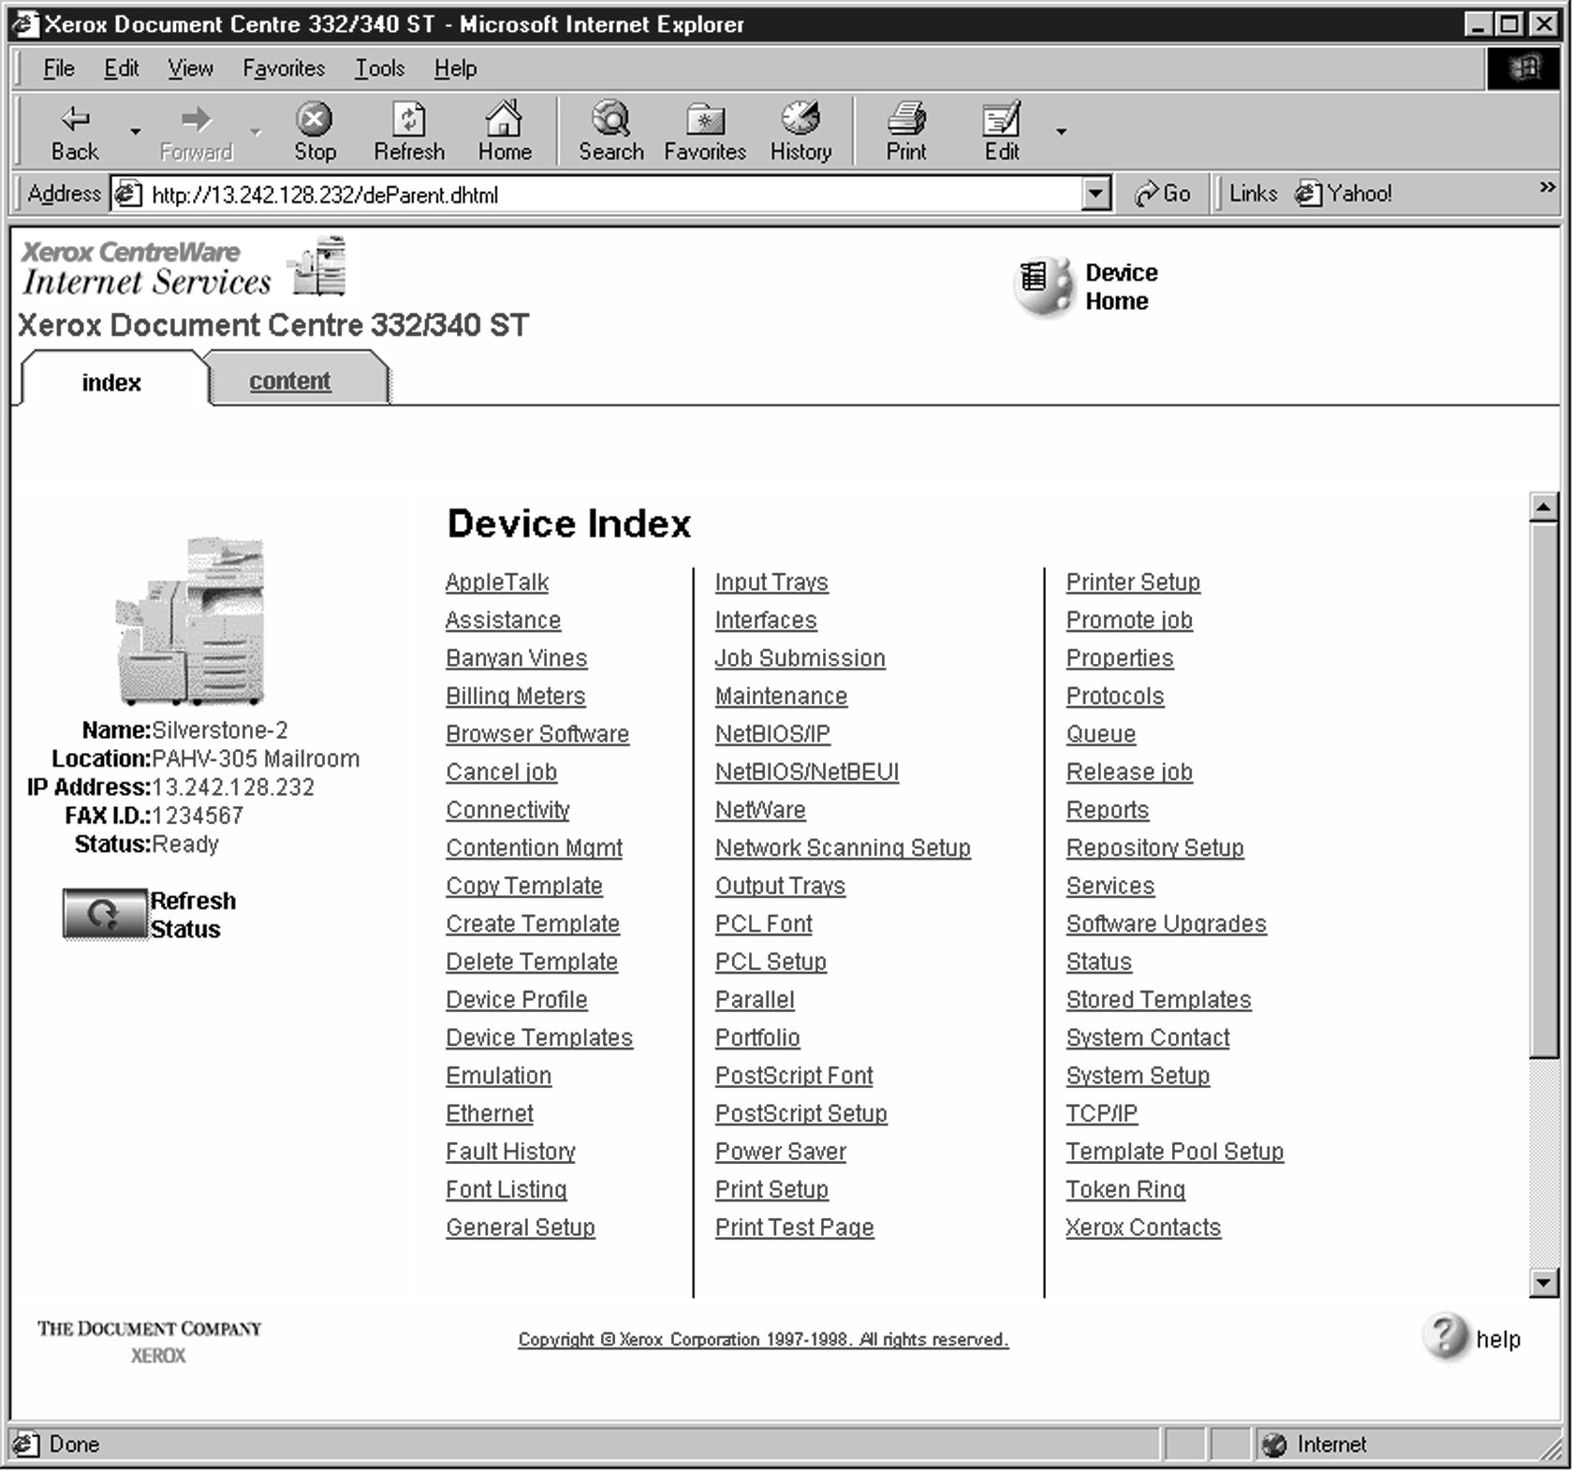

1. Select **Stored Templates**.

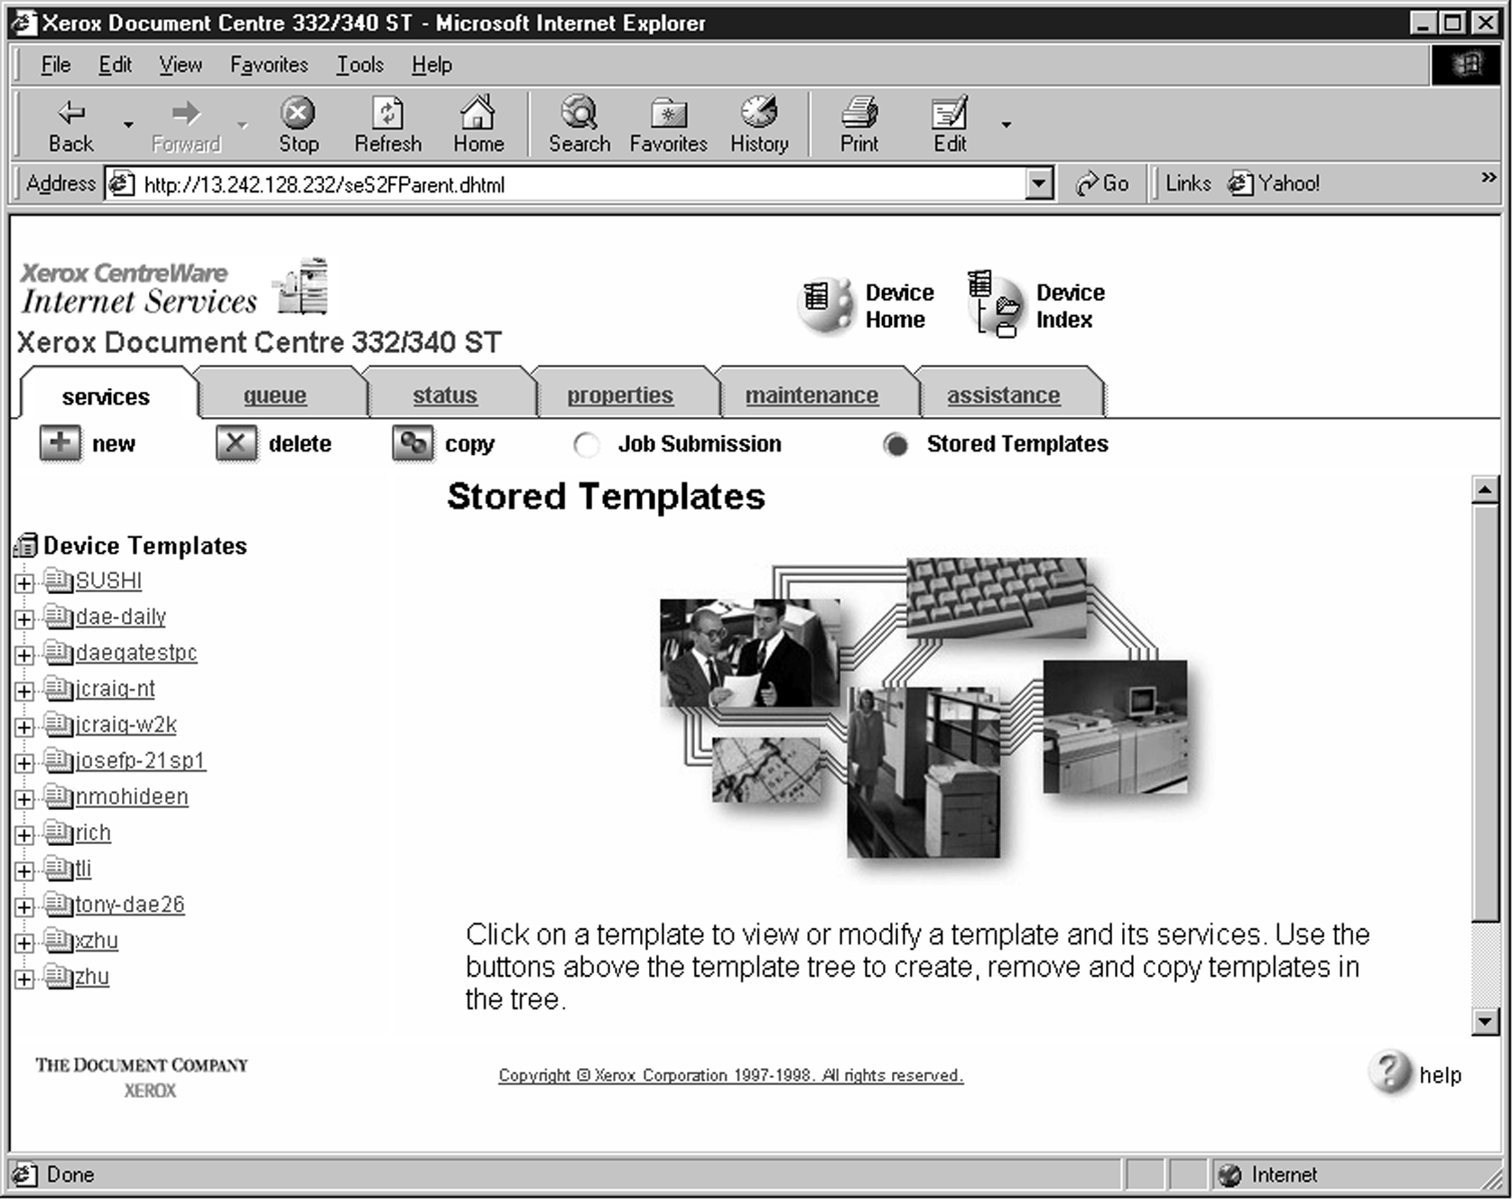

1. Select **[+] new**.

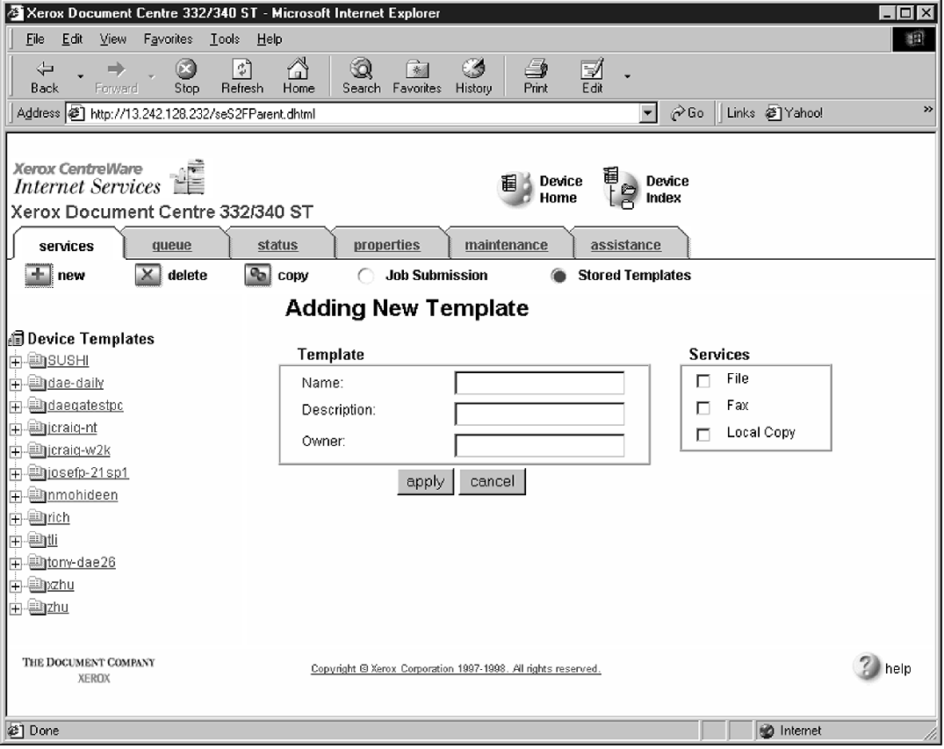

1. In the Template fields, enter a name for the template in the **Name** field. Leave the Description and Owner fields blank.
2. Under **Services**, select **File**.
3. Click **apply**.
4. If you see the following dialog box, click **Yes**.

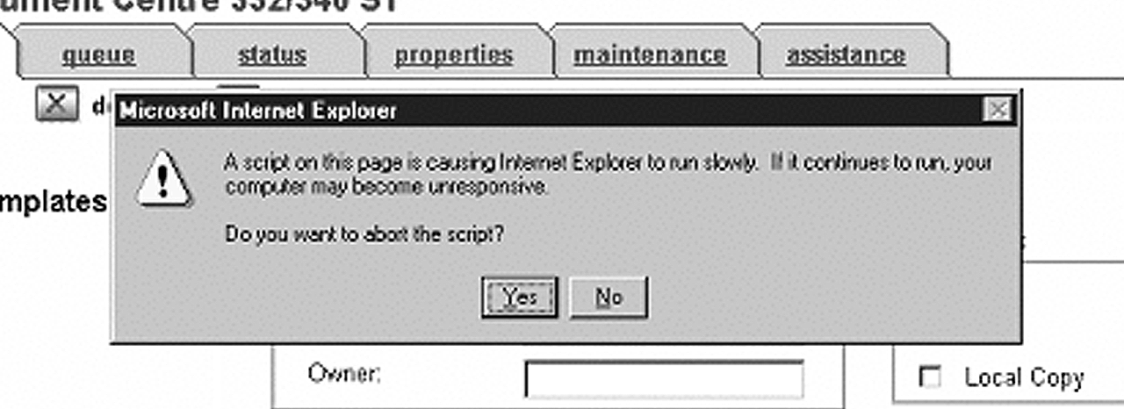

1. Click the browser’s **Refresh** button. You should see the name of the new template in the list of Device Templates.

List of Device Templates

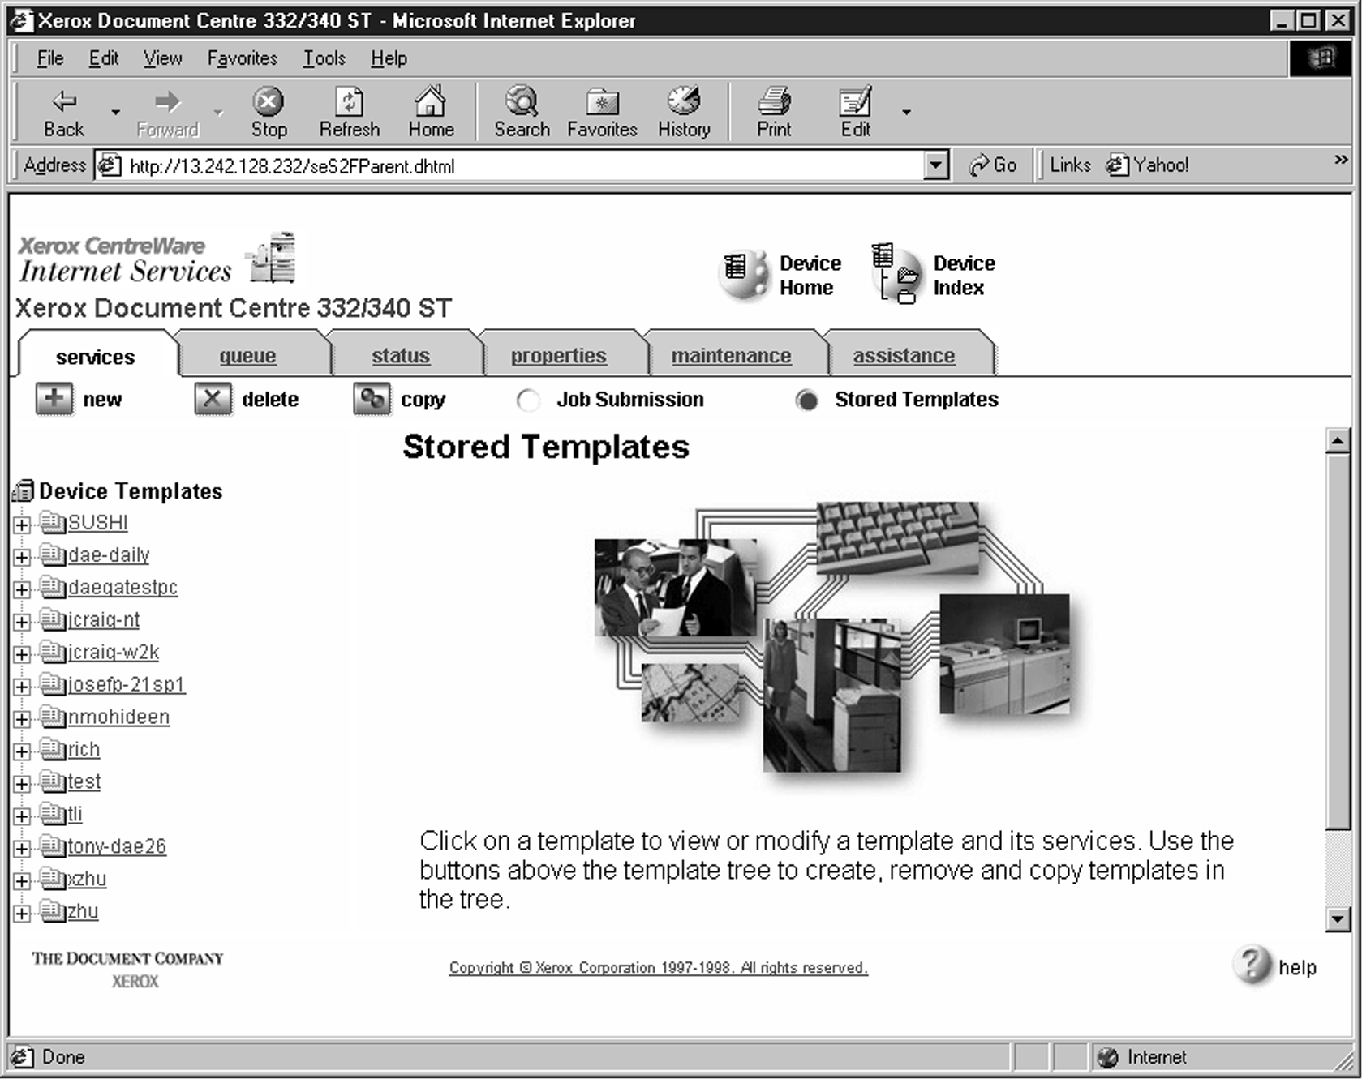

1. Click on **[+]** next to the name of the new template in the list of Device Templates.
2. Click **Scan** and verify the scan settings. Typically, the default settings are used, however click **Edit** if you want to change them.

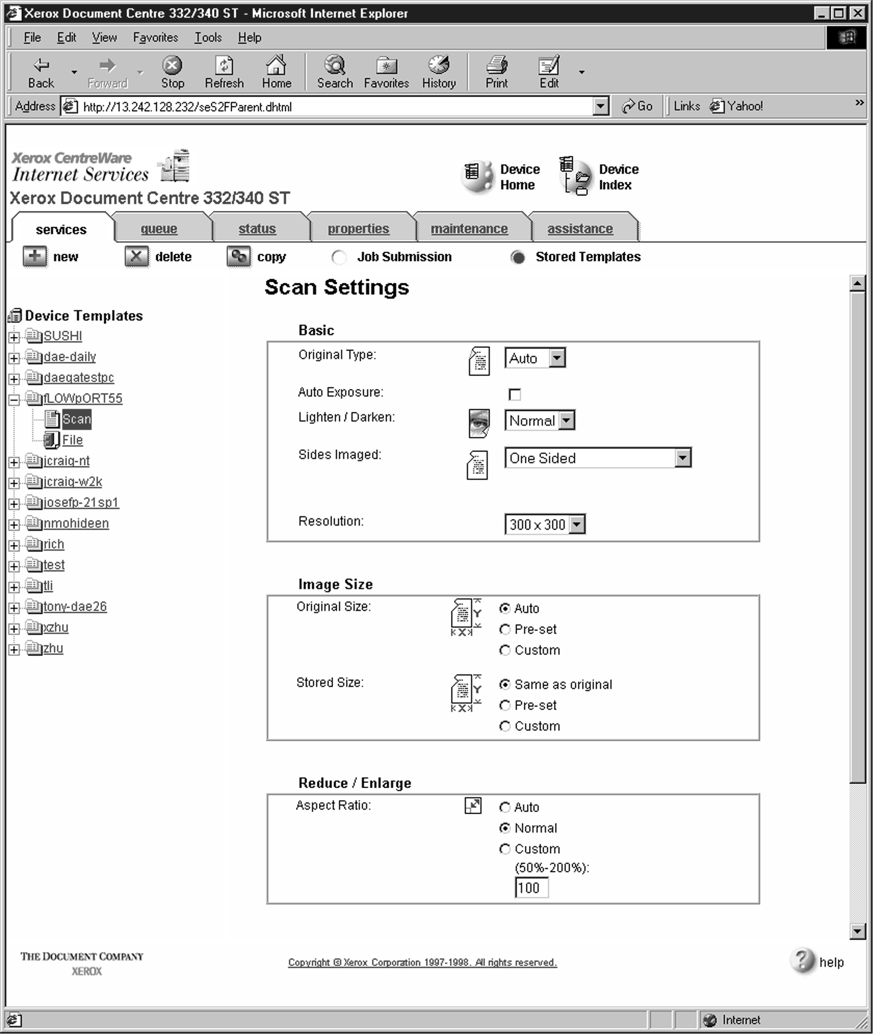

Text

1. 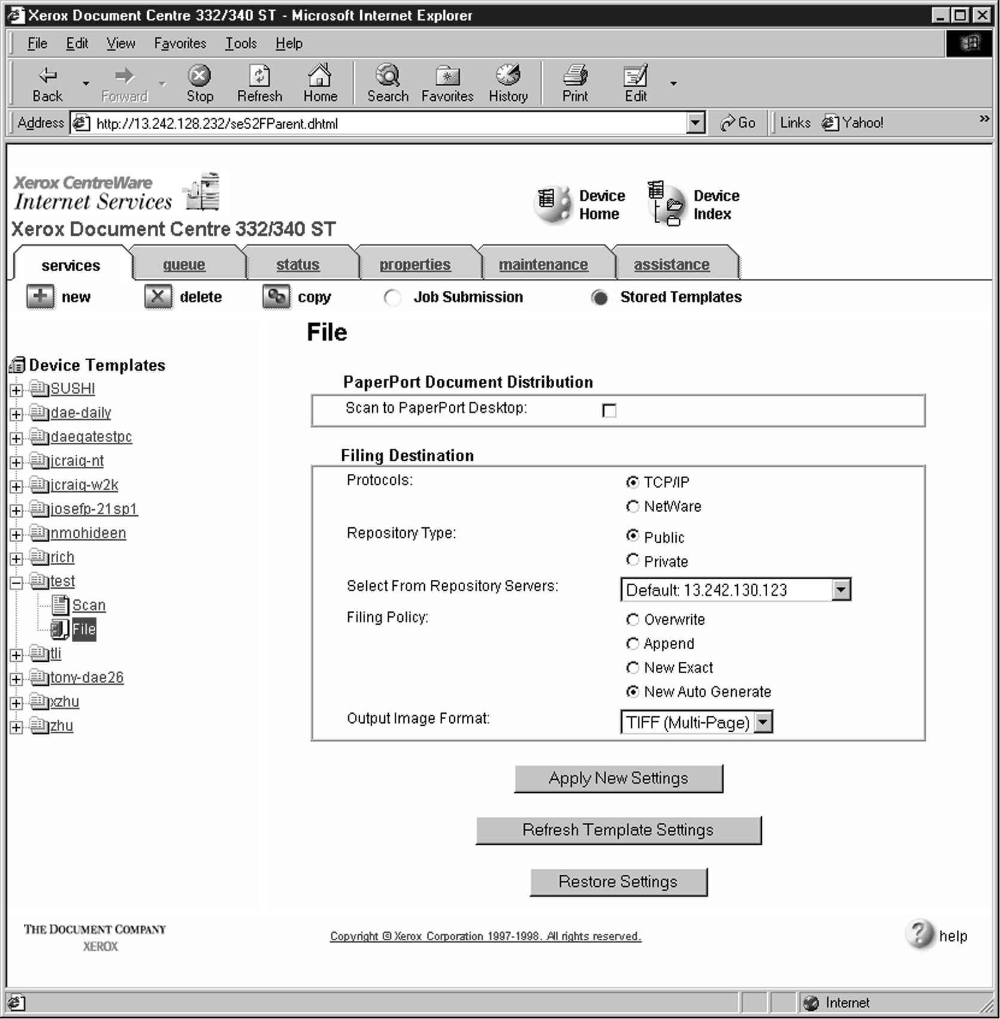Click **File**.
2. Under Stored templates, select the following: **TCP/IP**, **Public**, **Default** (or the repository designated for FlowPort), **New Auto Generate**, and **TIFF**

**(Multi-Page)** . Then, click **Apply New Settings**.

1. The Document Center is now configured to scan to the FlowPort server.

## Testing the FlowPort Template

To check that the Document Centre is ready for FlowPort use, perform the following test:

1. At the Document Centre, place a document in the scanner.
2. Select the FlowPort template and select **Scan**.

***Note: If the Document Centre is properly configured, a DC confirmation sheet will be printed confirming that the scan to FlowPort was successful, otherwise an error report with some specific failure notice will be printed. If the scan to FlowPort was successful a FlowPort confirmation sheet will also print.***